[enter your name]
[enter your school/department]
[enter your PhD University of study]
[enter current university if different]
ORCID: [enter your ORCID url]
[enter title of your research]
submitted for the category of
GW4 Early Career Publishing Prize 2023
Hosted by

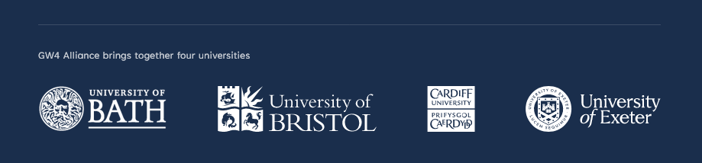
Thank you for your interest in the GW4 Early Career Publishing Prize. Please make sure you have read all the Supporting Information for you and your PhD supervisor before an application is submitted. The application should consist of:
- A completed copy of this form
- A sample chapter from your thesis
Please submit these or questions about the process to open-research-prize@bristol.ac.uk
The deadline for submissions is 23:59PM on Tuesday 7th November 2023.
The winner will be notified by Monday 20th November and will be invited to a celebratory ceremony on Thursday 23rd November when the ECR Monograph Prize will be announced.

Your Details
Name:

Email address:

Phone number:

ORCID:
You must have an ORCID to be eligible for this prize. If you don’t already have an ORCID please register for a free ID at http://orcid.org/

GW4 University of study for PhD:

Current Institution if different:

Thesis Details
Thesis title:

Link to online thesis:

Year of completion:

Name of supervisor(s):

Supervisor’s Supporting Information
To be completed by the Supervisor in support of the application. If a PhD has multiple supervisors, only one needs to complete this section.
Supervisor’s name:

Supervisor’s email address:

Supervisor's supporting statement:
What is the significance of the proposed book, and what does it bring to the subject area that is new? How has the applicant demonstrated their ability to write and edit their research in response to editorial comments? Any other information that is relevant to this application.
Please use as many lines as required.

Thesis examination:
Please indicate if the thesis received a Letter of Excellence, and the level of corrections required (check each box that applies; one box minimum must be ticked).
☐ Letter of Excellence
☐ Thesis awarded with minor corrections only
☐ Candidate received a strong recommendation to publish as a monograph in the examiner’s comments
Supervisor’s signature:

Applicant’s Open Research Supporting Statement
This statement should describe one or more of the following:
- evidence of excellence in one of the open research practices listed on our prize pages (e.g. made underpnning data openly available, or incorporated open and participatory methods in the design and conduct of research).
- evidence that the research has been made possible due to the open research practices of others (e.g. has made clear use of the FAIR data/preprints/etc. of other researchers)
- a strong case that publishing open access would be of especial benefit and importance due to the nature of the topic/subject (e.g. multidisciplinary work addressing global challenges and the SDGs)

Applicant’s monograph proposal (max 600 words)
Outline the publication’s scope and coverage, and highlight its originality. You could also include details about how you anticipate transforming your thesis into a monograph.
You should consider:
- What themes, concepts and ideas will you develop?
- Why does a book need to be written on your proposed topic and what is original about the content or your particular approach?
- What is the work’s topicality or academic or policy relevance?
- What, if any, are the deliberate omissions? And why?
- What impact would you like your book to have?

Provisional list of Chapters
This should include chapter synopses of max 100 words.

Publishing Agreement Conditions
The winner of the Early Career Publishing Prize will see their monograph proposal taken through the full Bristol University Press (BUP) commissioning process (including peer review), with the BUP Editorial Board signing off a monograph which meet BUP’s rigorous requirements.
If your proposal is commissioned, publishing fees will be paid, and commissioned authors will be fully supported through the publishing process.
Publishing with BUP will entail the following conditions:
- The volume will be published under a Creative Commons licence.
- You secure the proper authority from 3rd party rights holders to use their content. It will be your responsibility to ensure all appropriate copyright permissions are in place (BUP can offer advice on this).
- You will sign a publishing contract that agrees the relationship, liabilities and responsibilities between you and BUP, including timescales for delivery etc.
- None of the content published will be unlawful, discriminatory, or otherwise ethically inappropriate.

Exclusivity Declaration
Please sign below to confirm that the proposal is not currently being considered by any other publisher and that you will wait for an Editorial Board decision before submitting elsewhere.

Signature:

Date:

